
A Recognised College of University College Dublin
SCHOOL OF EDUCATION

Essay/Assignment Cover Sheet

Name of Student: Karla-Louise Kirwan

Course: BA in Education and Design/Fine Art
Submission Date: 04/01/2022
Lecturer/tutor Dr. Andrew Wall
Essay/Assignment title Meritocracy and the struggle of Dyslexia
Criteria | Ex | VG | Good | Fair | Poor | Comment
Introduction (statement of problem, response to task)
Range and use of appropriate sources
Development of argument (analysis, interpretation)
Conclusions (application, findings, outcomes)
Presentation, language, academic conventions

Please tick Y/N for Profile of Needs

General comment:

Indicative grade:
Tutor: __________________________________
Date: __________________________________
Copy of this sheet must accompany all written submission


Introduction:
I have chosen this image as it depicts a moment where now reflecting on it, I discover that the myth of meritocracy was exactly that, a myth.
In this essay we aim to delve into one of the most complex ideologies that presents itself within the education system, an ideal that is problematic for both student and teacher. This carves a lack of compassion into society for those beginning in this case their education journey at a disadvantaged starting point. Through this investigation, using the neurological learning disability of dyslexia. We will weigh up the imbalanced comprehension on the “ladder of opportunity” (Wall,2021) towards those with dyslexia. Along with the unintentional damage of the Irish education system and how that effects student.

Meritocracy: Definition
Meritocracy, according to the Collins Dictionary “is a society or system in which people get status or rewards because of what they achieve, rather than because of their wealth or social status” (Collins ,2021). This theory applies to aspects of life such as the ideal of success. Meritocracy therefore states that a student that comes from a socio-economic disadvantaged background can amount to the same level of success as another student that comes from a more financially stable background. Meritocracy does not believe in circumstances that can disable from persons amounting to their full educational prosperity. (Crash Course, 2018). Due to the extended believe everyone has the equal opportunity to achieve, meritocracy does not account for situations and circumstances in which we cannot control, such as caring for family, being late to class, part-time work, unaffordable grinds fees and learning difficulties.
This is a difficult theory to comprehend therefore attached is a cartoon that illustrates the basis of meritocracy. Through examining this image, it becomes quite clear that the animals depicted do not all have the same foundation of opportunity. They will each encounter their own challenges due to the circumstances they began with. For that reason, they may lose faith in themselves, their abilities, feel insufficient and not make progress. Unfortunately, this is our education system, it challenges individuals through a broad spectrum not taking into consideration their circumstances.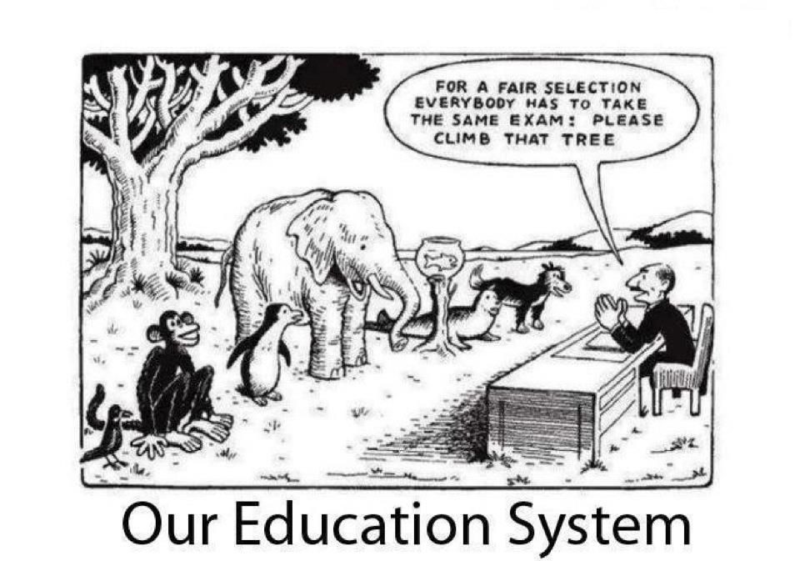
(Lands,2012)-cartoon

Is Meritocracy Damaging to Society?
Some theorists argue that the idea of meritocracy is damaging to society, especially within the academic society. As it is understood that schools value hard work to guarantee success but there is some indication that in the western world some people believe they deserve success because of their social status or even gender (Wiederkehn et al. (2015).Its widely accepted that hard work is the key to success in a school setting, but regrettably there is extensive evidence that shows such defining factors as social class, gender even sexuality give teachers an indicator of a student’s preliminary grades and success rate (Wiederkehn et al. 2015).This feeds into stereotyping and assumptions about people and doesn’t allow for students to be educated in a unbiased ways or for students to not view their academic career as a competition against their peers who may have improved social situations therefore can lead to a divide in social classes within institution, “Meritocracy has created a competition that, even when everyone plays by the rules, only the rich can win”(Marlovits, 2019).

Research into Mindset Correlation and Success
There is fascinating research into the mindset of students and how our education system plays a vital role in mindset. Referring to the illustration above, mindset can also enable student to coax their way around obstacles and or challenges. According to Stanford University Researcher, Carol Dweck, students with a fixed mindset often hold success because of intelligence and one that cannot improve, while students with a growth mindset see intelligence to progress (Bokas, Rock, 2015). Under the Neuroscience Bases of Learning states “Different learners’ networks may differ, in accordance with the person’s neuropsychological strengths and predispositions, and with the cultural, physical, and social context in which the skills are built.” (Immordino-Yang,2010. p.312) This defines people as having been born with various strengths in different sectors due to our physiological makeup. This is an indication that if our education system were altered to suit the needs of student’s, the ideal of success could be developed into a concept that is accessible to everyone no matter their social class, gender, finances etc.

The Unfairness of the Education System
The Irish education system like many, is advertised as an inclusive and fair ground to educate the people of Ireland. Depending on your circumstances you may lean towards one of the two; fair or unfair. The defining factors in this sub-section are social class, religion, and gender, it is indicated that these factors can indicate privilege ‘gender, class, race, ethnicity- that separate those who are routinely privileged from those who are not’(Cahill,2015). Ireland is classified as a modern society that has tried to tackle issue of inequality within academia such as the Equal Status Acts, The Equality Act of 2010 and social inclusion schemes such as DEIS (Delivering Equality of Opportunity in Schools). The Equal Status Acts and The Equality Act of 2010 both state that a discrimination across the protected characteristics (disability, race, sex, gender reassignment, pregnancy, religion, age, and marriage) are not tolerated (Schools and Equal Status Act,2005). While the DEIS scheme aims to improve “the path of educational opportunity for those who come to education at a disadvantage … to break the cycle in communities with high concentration of disadvantage” (Government of Ireland,2017. p.4).
However, these contingency plans do not apply to the hundreds and thousands of students with learning difficulties. In the next section of this essay, I will be discussing how meritocracy, disadvantage, and dyslexia effect students in relation to success and progression.

Dyslexia
Dyslexia is a neurological condition that “involves difficulty reading due to problems identifying speech, sound and learning how they relate to letters and words” (Mayo Clinic,2011). These symptoms are spotted usually at young developmental ages within schooling. Unfortunately, it is generally accepted that secondary schools are a place which unknowingly to the education system makes it exceedingly difficult to diagnose/cope with dyslexia “The Irish school system is not adequately resourced to identify dyslexia” according to the chief executive of the Dyslexia Association of Ireland, Rosie Bisset (McGuire,2015). From examining the reports around the harsh reality of dyslexia this quote from the Irish Times highlights the inequality within the system “children with dyslexia are in luck if their parents have money, but if they don’t, the learning disability is less likely to be picked up …” (McGuire,2015).

The bitter reality of being affected by dyslexia is as follows: insufficient testing for dyslexia which averages at six hundred euro for an educational assessment with a learning psychologist (Actualise,2021). Along with the costly emotional price of being diagnosed with dyslexia “dyslexic people can be devasted when they receive an evaluation of dyslexia” (Aston,2019) having lived their academic lives being perceived as unintelligent and dazed, it can be a shock to learn the reasoning. This connection between dyslexia and trauma comes from a report by the British Dyslexia Association. An article informed by this report from counselling Directory UK describes a dyslexic diagnosis as “Having lived a life under a cloud of believing they were rather thick and stupid; it is alarming to discover things could have been vastly different. This realisation can create emotional soup” (Aston,2019). These facts alone show the sheer inadequacy of the education system and how the system does do not cater for individuals but for the vast population, dyslexia and other learning difficulties can prevent a person from reaching their full potential, due to scarce resources from the Department of Education, late diagnoses because of financial issues or public waiting lists, insufficient encouragement to preserve despite their disability and inequality. When you take all these factors into consideration you may have very few kids that overcome these obstacles and achieve at the same level or higher than their peers.

Relating my picture to Meritocracy and Dyslexia
The photograph present above depicts a young girl who had been at a disadvantage for most of her educational journey, only diagnosed at age twelve after 8 years of primary education or 8 years of struggle and inadequacy. It shows a special moment of success after months of constant demanding work, extra time spend re-writing notes, not socialising with friends to learn extra content, reading novels not once but twice to understand the meaning, to finally acquire the same accomplishments as her classmates who did minimum work. It is said that “the dyslexic brain is wired differently, and it takes people a lot longer to process, access and retrieve information” (McGuire, 2015). This factor puts students with dyslexia at a disadvantage in exam settings before they even begin to learn curriculum. Especially in second level education it can be exceedingly difficult to gain access to resources to aid learning disabilities due to the disability not being “bad enough” (McGuire, 2015) to warrant accommodation in their education. According to Dr. Cogan, an educational psychologist, and dyslexia researcher “there are still too many barriers in dealing with dyslexia in Ireland” (McGuire, 2015). These barriers can vary from person to person, such as no resources, insufficient learning support time and not having access to assistive technology. This often prevent students from achieving their full potential due to not accessing help. Additionally, Rosie Bisset the Chief Executive of the Dyslexia Association of Ireland voices how many dyslexic students may have had turbulent interactions with schoolwork and have developed ways to completely avoid reading or writing within classes. Bisset also states how disheartening it can be for a dyslexic student who fears writing to receive an abundance of error marks (Holden, 2013). Through the analysis of dyslexic reports and articles it becomes clearer with every word that having a learning disability puts you at a disadvantage in the education system within Ireland and generates a difficulty to progress to the normal success of peers.

Conclusion
In conclusion, Meritocracy is a “functionalist view of the education system” (Wall, 2021), that holds the belief that the people’s success is dictated by their ability, however this concept does not consider circumstances which may disable people from achieving their highest success. Throughout this essay we delved into the complexity of dyslexia, how it can not only impact a student’s academic work but also their emotional development and self-worth. Additionally, in investigated the intricate nature of how these two topics intertwine to create a hostile environment for those within the system, we learned how the unfairness and disproportion of the education system plays a huge role in the sheer amount of undiagnosed learning disabilities and lack of open mindsets towards progression and improvement in education. For myself having first-hand experience of the system along with how issues orbiting around meritocracy, dyslexia, and the concern which student’s basis their value or accomplishments off individuals’ achievements who may have had an advantage or disadvantage starting point to them is extremely damaging to the developmental mind. Therefore, through my research I have come to a personal conclusion that this myth of meritocracy present in the education system is exactly that, a myth. Unfortunately, one that not very many with learning difficulties beat, but I can gladly say the girl above bet the odds all on her own.

Reference List:
- Actualise.ie (2021), Prices. Available at: https://www.actualise.ie/prices) insert
Accessed on: 12/12/21
- Aston, P, (2019), ‘The Human Cost of Dyslexia’, Counselling Directory, Published: 30/04/2019, Available on: https://www.counselling-directory.org.uk/memberarticles/the-human-cost-of-dyslexia
Accessed on: 12/12/21
- Bokas.A, Rock.R (2015) “Changing the Mindset of Education: Every Learner is Unique”, Getting Smart, May 24th, 2015. Available at: https://www.gettingsmart.com/2015/05/24/changing-the-mindset-of-education-every-learner-is-unique/
Accessed on:24/12/21
- Cahill, K (2015)’Seeing the Woods from the Trees: A Critical Policy Analysis of Intersections between Social Class Inequality and Education in Twenty-First Century Ireland’. 2015-12 Available at:https://scholar.googleusercontent.com/scholar?q=cache:rIwLOrKyWecJ:scholar.google.com/+inequality++in+education+ireland&hl=en&as_sdt=0,5&as_vis=1
Accessed on: 07/12/21
- Collins, (2021), COBUILD Advanced English Dictionary ‘Definition of ‘Meritocracy’ Available at: https://www.collinsdictionary.com/dictionary/english/meritocracy
Accessed on: 19/11/21
- Crash Course (2018), ‘Schools & Social Inequality: Crash Course Sociology #41’. Available at: https://www.youtube.com/watch?v=hYMk3Bk08NA
Accessed on: 24/12/21
- Government of Ireland, ‘DEIS Plan 2017’, Department of Education. Available at:https://www.gov.ie/en/policy-information/4018ea-deis-delivering-equality-of-opportunity-in-schools/
Accessed on: 11/12/2021
- Government of Ireland, ‘Schools and the Equal Status Act.’ (2005), Available at: https://assets.gov.ie/25063/a6e913a466344dce9530ce261b41d6c5.pdf
Accessed on: 02/12/2021
- Holden, L (2013), “Spelling Out the Needs of Students with Dyslexia”, The Irish Times, 10/12/2013. Available at: https://www.irishtimes.com/news/education/spelling-out-the-needs-of-students-with-dyslexia-1.1621963
Accessed on: 10/12/21
- Immordino-Yang (2010),’Neuroscience Bases of Learning’. Available at:http://impactofspecialneeds.weebly.com/uploads/3/4/1/9/3419723/neuroscience_bases_of_learning.pdf
Accessed on: 07/12/21
- Lands, B, (2012). ‘The Landscape of Learning: there is more than one way to climb a tree.’ Available on: https://www.thelandscapeoflearning.com/2012/09/please-climb-that-tree.html
Accessed on: 11/12/2021
- Mayo Clinic Staff (2011) Dyslexia, Available at: https://www.mayoclinic.org/diseases-conditions/dyslexia/symptoms-causes/syc-20353552
Accessed on: 19/11/21
- McGuire, P (2015),” Dyslexia: Do our schools have the tools to help?”, The Irish Times,21/04/2015. Available at: https://www.irishtimes.com/news/education/dyslexia-do-our-schools-have-the-tools-to-help-1.2178604
Accessed on: 29/11/21
- Wall, A (2021),” Educational Disadvantage”. Online Lecture. Sociology Module Year 1. NCAD,19/12/2021
- Wiederkehn.V.et al. (2015), Belief in School Meritocracy as a System-Justifying Tool for Low Status Students, Available at: https://www.frontiersin.org/articles/10.3389/fpsyg.2015.01053/full Accessed on: 11/12/2021

